# ASSIGNMENT 2

|  |  |
| --- | --- |
| Team ID : | PNT2022TMID04545 |
| Project Name : | Project – Plasma Donor Application |

1. **Create User table with user with email, username, roll number, password**

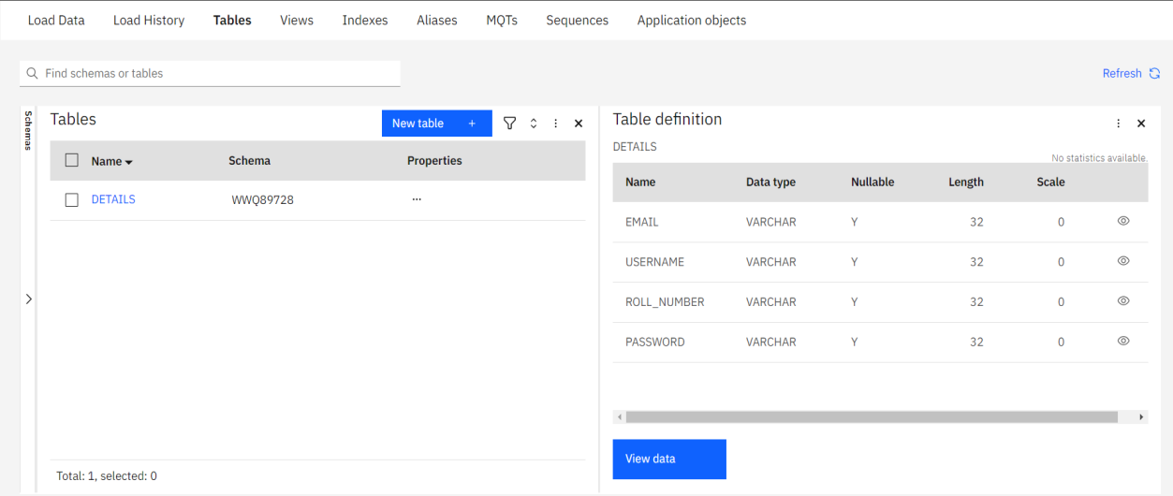

INSERT

INTO "DETAILS" ("EMAIL","USERNAME","ROLL_NUMBER","PASSWORD")

VALUES('dhiwaa@gmail.com','Dharanidharan',1,1111100000), ('dhina@gmail.com','Dhinagaran',2,1545522225), ('hari@gmail.com','Hariprasanth',3,7777777777), ('gowri@gmail.com','Gowrisankar',4,55555555555);

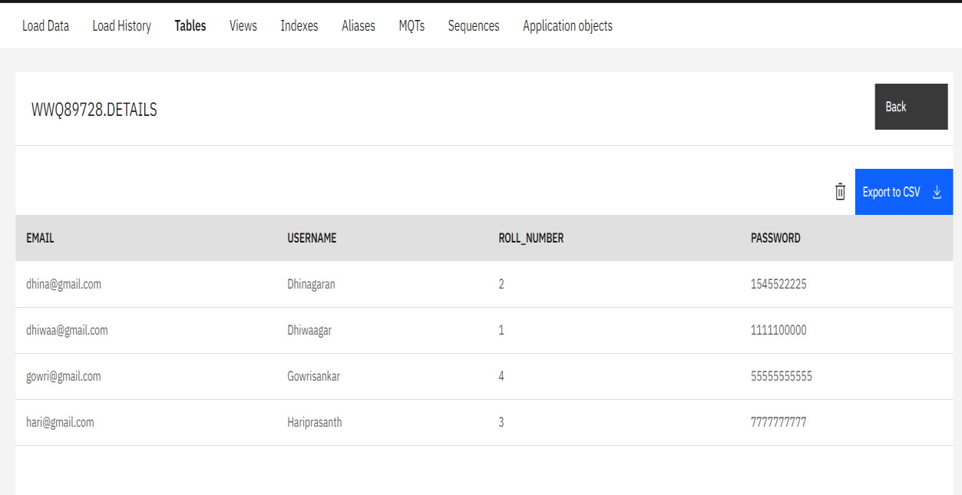

# Perform UPDATE,DELETE Queries with user table

UPDATE DETAILS

SET "EMAIL"='dhiwaagar@gmail.com' WHERE "ROLL_NUMBER"=1;

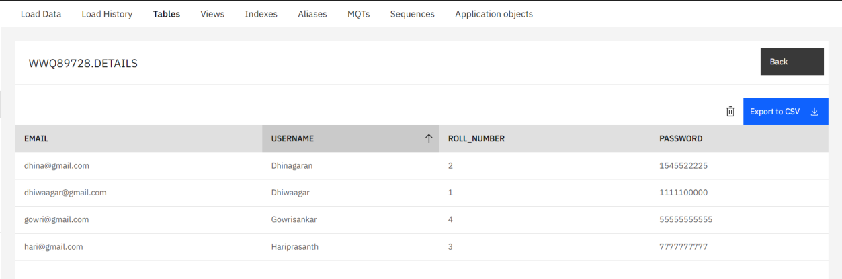

DELETE FROM DETAILS where USERNAME='sankar';

